<!DOCTYPE html>

<html lang="en">

<head>

<title>REGISTRATION FORM</title>

<meta charset="UTF-8" />

<meta name="viewport" content="width=device-width" />

<link rel="stylesheet" href="regis.css" />

<body background=""><br>

</head>

<body>

<div class="container">

<div class="center">

<h1>Registration Form</h1>

<form method="POST" action="">

<div class="txt_field">

<input type="text" name="name" required>

<span></span>

<label>Name</label>

</div>

<div class="txt_field">

<input type="email" name="email" required>

<span></span>

<label>Email</label>

</div>

<div class="txt_field">

<input type="username" name="username" required>

<span></span>

<label>User Name</label>

</div>

<div class="txt_field">

<input type="password" name="password" required>

<span></span>

<label>Password</label>

</div>

<div class="txt_field">

<input type="password" name="cpassword" required>

<span></span>

<label>Confirm Password</label>

</div>

<div class="txt_field">

<input type="phonenumber" name="phonenumber" required>

<span></span>

<label>Phonenumber</label>

</div>

<input name="submit" type="Submit" value="Sign Up">

<div class="signup_link">

Have an Account ? <a href="loginForm.php">Login Here</a>

</div>

</form>

</div>

</div>

</body>

</html>

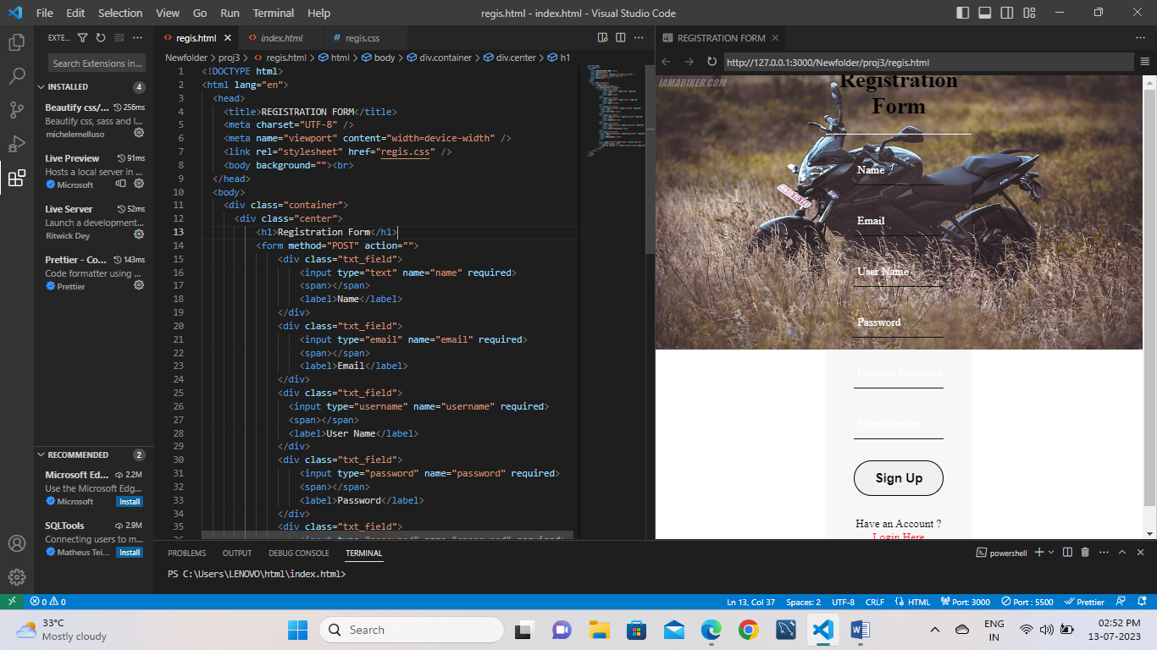

body{

background-image: url("https://e0.pxfuel.com/wallpapers/350/1017/desktop-wallpaper-pulsar-ns160-ns-200-black.jpg");

background-repeat:no-repeat;

background-size: cover;

}

.center{

position: absolute;

top: 50%;

left: 50%;

transform: translate(-50%, -50%);

width: 29vw;

background: rgba(169, 156, 156, 0.087);

border-radius: 10px;

}

.center h1{

text-align: center;

padding: 0 0 20px 0;

border-bottom: 1px solid rgb(255, 255, 255);

}

.center form{

padding: 0 40px;

box-sizing: border-box;

}

form .txt_field{

position: relative;

border-bottom: 2px solid #111010;

margin: 30px 0;

}

.txt_field input{

width: 100%;

padding: 0 5px;

height: 40px;

font-size: 16px;

border: none;

background: none;

outline: none;

}

.txt_field label{

position: absolute;

top: 50%;

left: 5px;

color: #ffffff;

transform: translateY(-50%);

font-size: 16px;

pointer-events: none;

}

.txt_field span::before{

content: '';

position: absolute;

top: 40px;

left: 0;

width: 0px;

height: 2px;

background: #2691d9;

transition: .5s;

}

.txt_field input:focus ~ label,

.txt_field input:valid ~ label{

top: -5px;

color: #2691d9;

}

.txt_field input:focus ~ span::before,

.txt_field input:Valid ~ span::before{

width: 100%;

}

.pass{

margin: -5px 0 20px 5px;

color: #cd3030;

cursor: pointer;

}

.pass:hover{

text-decoration: underline;

}

input[type="Submit"]{

width: 100%;

height: 50px;

border: 1px solid;

border-radius: 25px;

font-size: 18px;

font-weight: 700;

cursor: pointer;

}

input[type="Submit"]:hover{

background: #2691d9;

color: #000000;

transition: .5s;

}

.signup_link{

margin: 30px 0;

text-align: center;

font-size: 16px;

color: #050303;

}

.signup_link a{

color: #ff0f0f;

text-decoration: none;

}

.signup_link a:hover{

text-decoration: underline;

}

.HomeAbout{

width: 100vw;

height: 25vh;

}

